**The New Zealand Diploma in Business (Level 6) – Accounting strand**

* 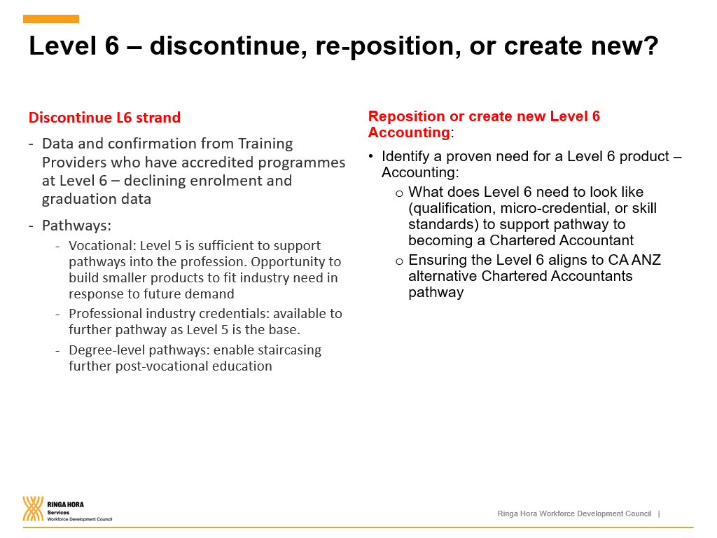Total of 13xx graduates of the accounting strand only in 2020.